**Practice Project 5**

**Longest Incremental Sequence**

**Sai Krishna Rajagopal**

**04-03-2022**

**GITHUB Repository URL:** [**https://github.com/SaiKrishna6699/CoreJavaTraining.git**](https://github.com/SaiKrishna6699/CoreJavaTraining.git)

**Technical Summary:**

1. **Java**
2. **Eclipse**
3. **Git**
4. **Java:**

The Arithmetic Calculator was developed in Java Programming Language using the concepts of Variables, data types, operators, type casting, control statements, class, objects, access specifiers, and core keywords like final.

* The Application is fully functional and working perfectly with No Exceptions

Short Summary of code:

* + The static Incre_SubSequence method contains the Working of the application.
  + In the main method the program asks the user to give an array to check the LIS in the Array.
  + Method takes the Array data from the main method given by the user.
  + In the Incre_SubSequence method has two parameters Arr[] and Arr _length.
  + An Array is initialized as Seq_arr and this array gets value 1 when the sequence is checked in the Array given by the main class.
  + A inter LIS is initialized the value gets incremented by Sub of Seq_Array.
  + This the value of LIS.
  + Finally, the max will be the output of the code.

1. **Eclipse:**

Eclipse is the IDE used to Write the code. It is a very programmer friendly and easy to use application.

1. **Git & GitHub:**
   1. Git is the version control system used to store the data in a remote Repository.
   2. GitHub is the remote data base contains repository which is used to store the data.

Git Commands used:

$git init

$git remote add origin “[**https://github.com/SaiKrishna6699/CoreJavaTraining.git**](https://github.com/SaiKrishna6699/CoreJavaTraining.git)”

$git remote -v

$git add .

$git commit -m “First Commit”

$git branch -M main

$git add Longest Incremental Sub Sequence

$git push -u origin main

1. Screenshots:

Code:

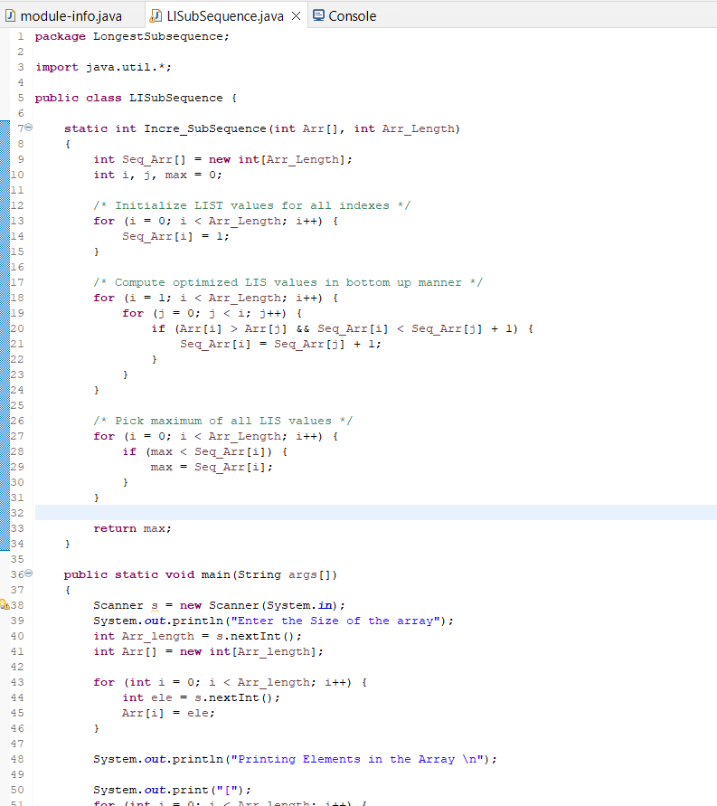

Output Sc shot:

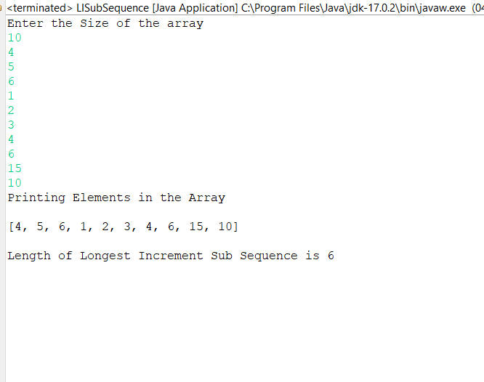

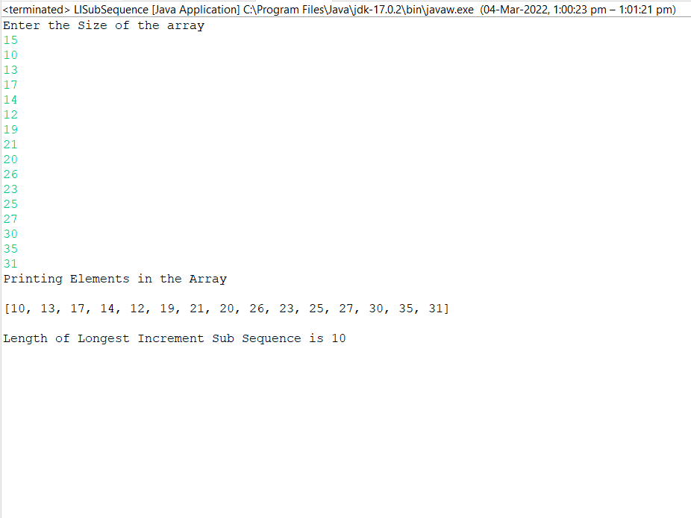

Git Commands:

